**Name**: Venkata Lakshmi Sasank Tipparaju

**Student ID** #700738838

Advance Database Systems

CS5600 & CRN:13892

1. **Create the B+Tree Index(m=4) after insert the following input index: (10 pts.)**

**4, 3, 2, 5, 6, 4, 9, 10, 12, 8, 5, 7, 8, 1, 5, 2, 3, 6.**

*(Note: Please show each step, not only the final answer.)*

**Answer:**

M = 4 (Max number of children)

Min # of children = 2

Min # of keys = 1

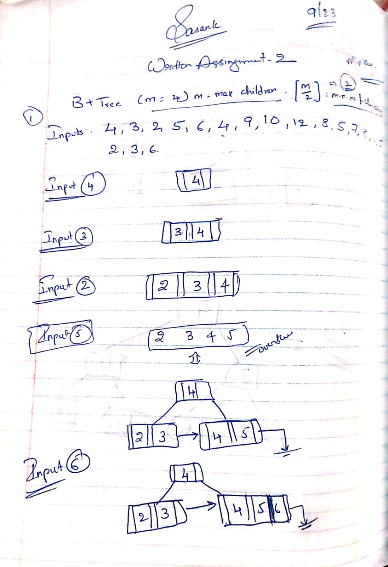

1. **Regarding to the following B+Tree Index(m=3):**

**If we delete index key 8, 5 and all 2s what is the B-Tree Index after the deletion? (5 pts.)**

*(Note: Please show each step, not only the final answer.)*

**Answer**:

Max number of children M = 3

Minimum # of children = 2

Minimum # of keys = 1

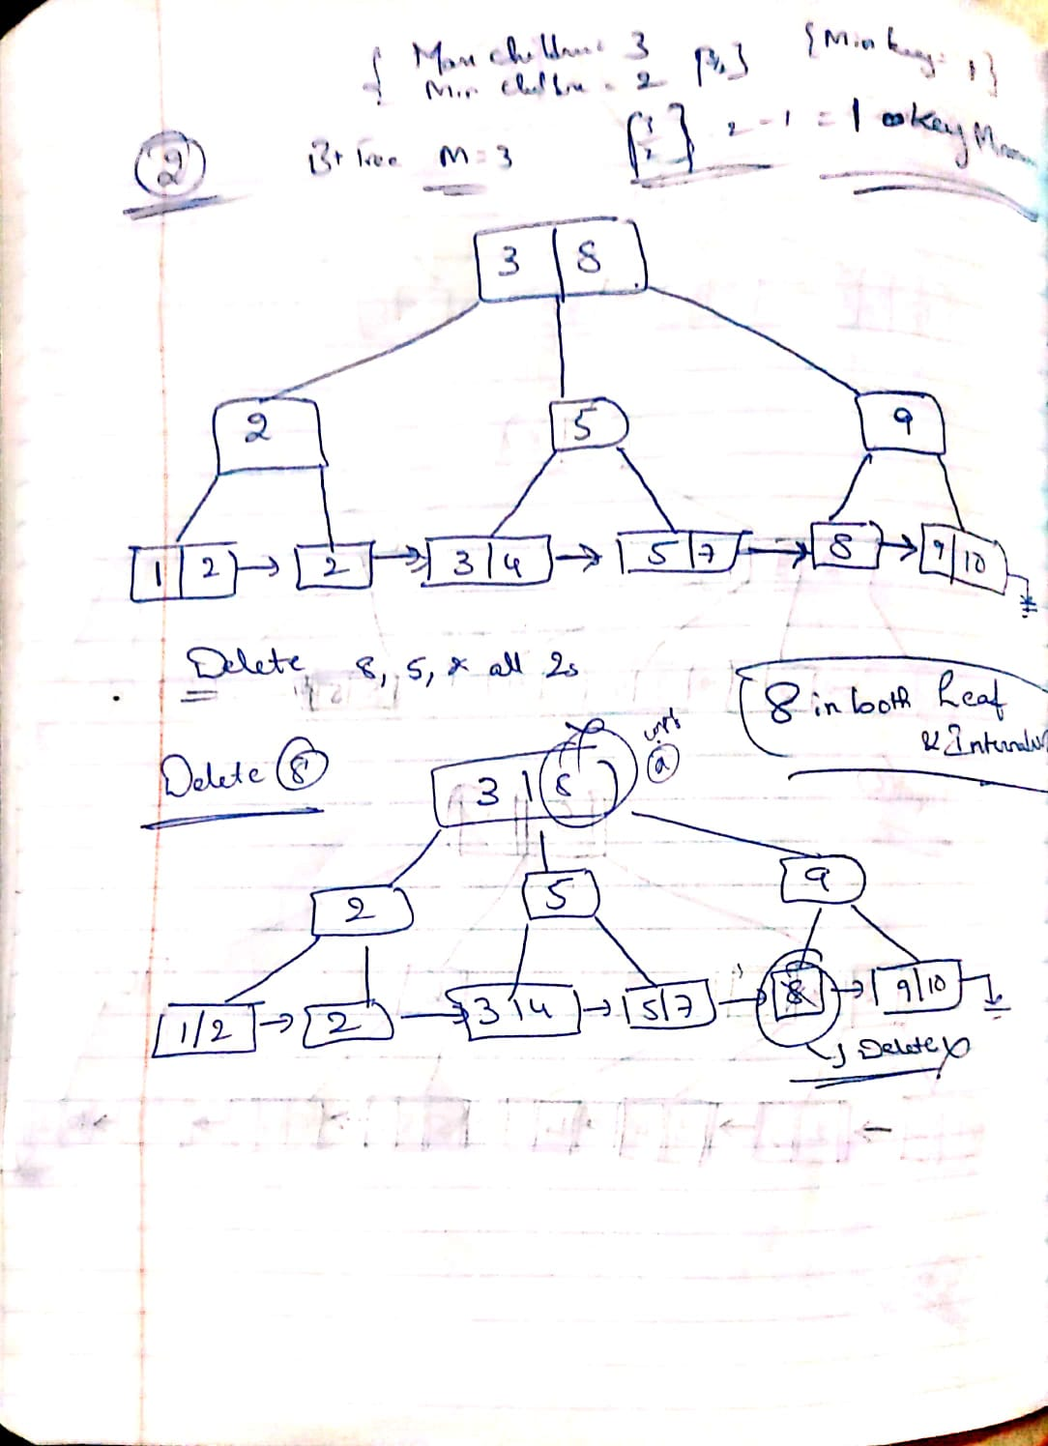

1. **Linear Hash: Create the hash table from the following index key values, with the bucket size = 3, and initial hash function: hash1 = index value mod 2.**

**Given input index keys: 1, 3, 2, 10, 8, 17, 5, 4, 16, 9, 11, 13, 6, 9.**

* 1. What is the hash table after round 0? (5 pts.)
  2. What is the final hash table? (5 pts.)

*(Note: Please show each step, not only the final answer.)*

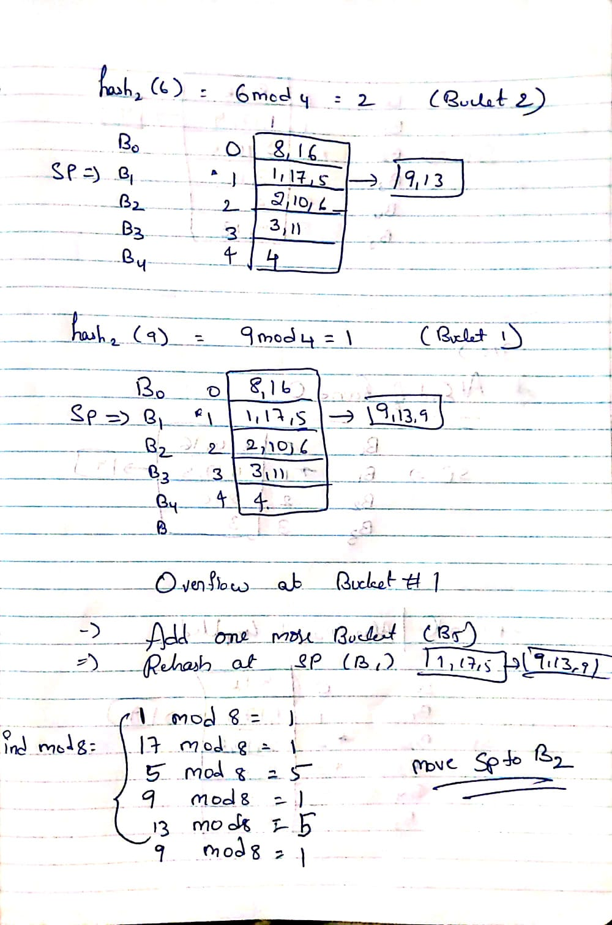

------------------------------------------------------------ End Of Document ---------------------------------------------------